The Daily Province issue of May 14, 1938 had a photo and column title “Dewdney Farmer Specializes in “Super-grade” Rhubarb, subtitled Nameless variety produces thick, tender and richly colored stems.
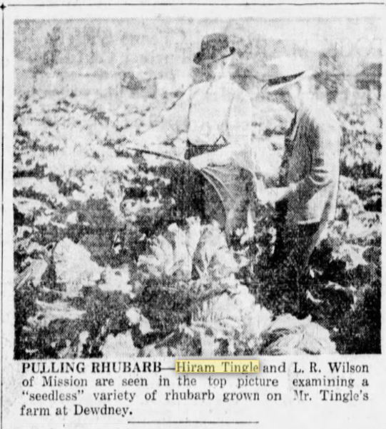
The article states that:
Hiram (sic) Tingle had a three-acre patch of rhubarb on his 160 acre rented farm. Mr. Tingle gives all the credit to his two sons, Jim and George who at the time of the visit to the farm this week were out in the field pulling stems that would delight the most exacting gourmet. Almost as wide as the width of four fingers, deeply colored and averaging nearly two feet in length, the stems immediately brought to mind thoughts of rhubarb sauce, rhubarb pie and other delicacies that are part of the menu at this time of year. Yet, in spite of their size the stems are tender and sweet, considerably less acid than the average run of the field rhubarb. Moreover, the rich, red color of the stems is not just skin deep, but extends into the marrow.
Five years ago, while living on another farm, the Foley estate, near his present location, Mr. Tingle secured three roots which he believes originally came from France. Whether this is so or not is not essential, as the fact remains that in five years he developed from those three roots a rhubarb plantation second to none in quality of the product in this province. The present field is only a year old, but even now Mr. Tingle estimates a yield of 400 boxes an acre, and there are 42 pounds to a box. Bigger yield is expected next year.
Mr. Tingle is not at all certain of the name of the variety, although he has been told that it may be Sutton Seedless. At least it is true that the variety is seedless. Only a few roots send up seed shoots the first year, none appearing in the subsequent years. The variety is virile, Mr. Tingle saying that the six rows of rhubarb which he had at the Foley estate were as vigorous as ever after five years in the ground.
An interesting fact about this rhubarb is that a few roots “go back” in other words, fail to produce true to type, but develop as a common garden variety.
A few family members still have rhubarb roots from the original Tingle rhubarb plants. We call it Tingle rhubarb. It is definitely a heritage plant.

